Project Planning Phase
Project Planning Template (Product Backlog, Sprint Planning, Stories, Story points)

Date | 10 October 2026
Team ID | SWTID-2026-7196
Project Name | AI-Weatherwise
Maximum Marks | 5 Marks

Product Backlog, Sprint Schedule, and Estimation (4 Marks)
Use the below template to create product backlog and sprint schedule
Sprint | Functional Requirement (Epic) | User Story Number | User Story / Task | Story Points | Priority | Team Members
Sprint-1 | Registration | USN-1 | As a user, I can register by entering my name, email and password. | 3 | High
Sprint-1 | Registration | USN-2 | As a user, I want my password stored securely (bcrypt hashing). | 2 | High
Sprint-1 | Login | USN-3 | As a user, I can log in with my email and password and receive a JWT token. | 3 | High
Sprint-2 | Login | USN-4 | As a user, I can update my profile name and password. | 2 | Medium
Sprint-1 | Favourite Locations | USN-5 | As a user, I can add a favourite city with its country. | 3 | High
Sprint-1 | Favourite Locations | USN-6 | As a user, I can view all my favourite cities. | 2 | High
Sprint-2 | Favourite Locations | USN-7 | As a user, I can update or delete a favourite city. | 3 | Medium
Sprint-1 | Weather | USN-8 | As a user, I can fetch the current weather for a city. | 3 | High
Sprint-2 | AI Insights | USN-9 | As a user, I can get a natural-language weather summary for a city. | 5 | High
Sprint-2 | AI Insights | USN-10 | As a user, I can get clothing and outdoor activity recommendations. | 5 | High
Sprint-2 | AI Insights | USN-11 | As a user, I still get results when API keys are unavailable (fallback mode). | 3 | Medium
Sprint-1 | Weather | USN-12 | As a visitor, I can view current weather without creating an account. | 2 | High
Sprint-3 | User Management | USN-13 | As an admin, I can view all registered users. | 3 | High
Sprint-3 | User Management | USN-14 | As an admin, I can suspend or delete a user. | 3 | Medium
Sprint-3 | Monitoring | USN-15 | As an admin, I can check API health and system statistics. | 2 | Medium

Project Tracker, Velocity & Burndown Chart: (4 Marks)
Sprint | Total Story Points | Duration | Sprint Start Date | Sprint End Date (Planned) | Story Points Completed (as on Planned End Date) | Sprint Release Date (Actual)
Sprint-1 | 18 | 6 Days | 10 Oct 2026 | 15 Oct 2026
Sprint-2 | 18 | 6 Days | 17 Oct 2026 | 22 Oct 2026
Sprint-3 | 8 | 6 Days | 24 Oct 2026 | 29 Oct 2026

Velocity:
Imagine we have a 10-day sprint duration, and the velocity of the team is 20 (points per sprint). Let’s calculate the team’s average velocity (AV) per iteration unit (story points per day)

AI-Weatherwise: Each sprint is 6 days and the team plans 44 story points over 3 sprints (18 + 18 + 8). Average velocity = 44 / 3 = 14.67 story points per sprint. Average velocity per day (AV) = 14.67 / 6 = 2.44 story points per day.

Burndown Chart:
A burn down chart is a graphical representation of work left to do versus time. It is often used in agile software development methodologies such as Scrum. However, burn down charts can be applied to any project containing measurable progress over time.

https://www.visual-paradigm.com/scrum/scrum-burndown-chart/
https://www.atlassian.com/agile/tutorials/burndown-charts

AI-Weatherwise planned burndown: 44 story points over 3 sprints (18 days). Actual remaining work should be updated at the end of each sprint.
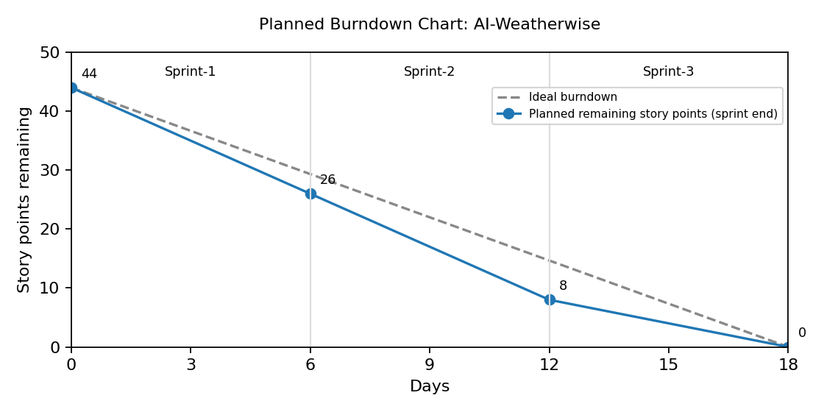
Reference:
https://www.atlassian.com/agile/project-management
https://www.atlassian.com/agile/tutorials/how-to-do-scrum-with-jira-software
https://www.atlassian.com/agile/tutorials/epics
https://www.atlassian.com/agile/tutorials/sprints
https://www.atlassian.com/agile/project-management/estimation
https://www.atlassian.com/agile/tutorials/burndown-charts

